Self-Contained Analytical Skating

Form Tracker

Design Review

Team 38 —​ Charles Hu, Jonathan Wang, Qian Ma

ECE 445 —​ Spring 2017

TA —​ Yuchen He

Contents

[1 Introduction 4](#_Toc476865693)

[1.1 Objectives 4](#_Toc476865694)

[1.2 Background 4](#_Toc476865695)

[1.3 High-Level Requirements 5](#_Toc476865696)

[2 Design 6](#_Toc476865697)

[2.1.1 High Level Description 6](#_Toc476865698)

[2.1.2 Device Software Finite State Machine 7](#_Toc476865699)

[2.2 Block Descriptions 9](#_Toc476865700)

[2.2.1 Power Supply 9](#_Toc476865701)

[2.2.2 Status LEDs 12](#_Toc476865702)

[2.2.3 Input Buttons 12](#_Toc476865703)

[2.2.4 Microcontroller(ATmega328P) 13](#_Toc476865704)

[2.2.5 microSD Reader 14](#_Toc476865705)

[2.2.6 Bluetooth Transceiver (HC-05) 16](#_Toc476865706)

[2.2.7 Inertial Measurement Unit (IMU) 17](#_Toc476865707)

[2.2.8 Force Sensitive Resistors with Passive Low-pass Filter 20](#_Toc476865708)

[2.3 Software Description 23](#_Toc476865709)

[2.3.1 Post Processing Software 23](#_Toc476865710)

[2.4 Calculation and Simulation 26](#_Toc476865711)

[2.4.1 Current and Power Calculation 26](#_Toc476865712)

[2.4.2 Sensor Resolution 27](#_Toc476865713)

[2.4.4 Data Collection Rate Justification 29](#_Toc476865714)

[2.4.5 Variable Load Current Testing Circuit Analysis 30](#_Toc476865715)

[2.5 Tolerance Analysis 31](#_Toc476865716)

[3 Ethics 32](#_Toc476865717)

[3.1 Ethics Justification 32](#_Toc476865718)

[3.2 Safety 32](#_Toc476865719)

[3.2.1 Device Overheating 33](#_Toc476865720)

[3.2.2 Battery Safety 33](#_Toc476865721)

[3.2.3 Hardware failure 33](#_Toc476865722)

[3.2.4 Mounting failure 33](#_Toc476865723)

[4 Cost and Schedule 33](#_Toc476865724)

[4.1 Cost Analysis 33](#_Toc476865725)

[4.1.1 Labor 33](#_Toc476865726)

[Table 13: Labor Cost 34](#_Toc476865727)

[4.1.2 Parts 34](#_Toc476865728)

[4.1.3 Grand Total 34](#_Toc476865729)

[4.2 Schedule 34](#_Toc476865730)

[Bibliography 38](#_Toc476865731)

# 1 Introduction

## 1.1 Objectives

As an essential part of figure skating and hockey, ice skating is not only the foundation of the professional plays, but also a widely popular recreational sport for the public all over the world. The increased speed and reduced friction on ice often brings about rising level of safety issues. Therefore, ice skating calls for extreme precision and intricate body position. However, most skaters have not received formal training on their skating forms. Even for people with professional instructors, the traditional ways of coaching they get relies heavily on visual inspection and depends on the instructor's experience. Thus, many skaters, including some professionals, are unaware of their bad habits in skating form, which might lead to more risks of injury and will overall waste energy.

Our goal is to design an affordable, easy-to-wear device that can help users increase efficiency in skating while reducing the chances of injury. This device can track the skating forms and provide feedback to the user. It will assist the process of evaluating the skater performance and identify some subtle, unwanted habits that are hard to notice through visual inspection. We aim to make this design small and straightforward to use, while being affordable so the general public can utilize its benefits and improve upon their skating forms.

## 1.2 Background

In the past decade, researchers have worked on the analysis of on-ice biomechanics measurements. A team from University of Calgary, Canada implemented a system to investigate the forward skating technique [1]. Their measurement system includes EMG electrodes, electrogoniometers (to measure knee and hip angles), accelerometers, instrumented insoles, and data acquisition unit. Another project carried out at McGill University, Canada focused on analyzing dynamic forces during skater landing using specially modified skates and a force transducer system [3]. The main issue with the previous projects on skating data collection is the high cost to replicate these devices. They require either a multitude of expensive sensors or customized skates with special design [2]. In addition, the convoluted connection between devices make the system cumbersome and inconvenient for frequent use. All these factors make the existing systems prohibitive to the public.

Based on the above analysis, we aim to make our skate form tracker easy to use and highly affordable. It can be easily attached to the front of the skates near the laces. Since it’s lightweight and small, it will be as non-invasive as possible to the user. It will also eliminate the complex wire connection so it’s straightforward to use for the public. Ideally, the price of the device should be below $20.

In terms of technique, ice skating involves a series of complex motions. To begin with, ice skating is very unintuitive, as all people naturally learn to walk and run on frictional ground. The complexity of skating can be broken down into three general steps. The first motion is opening the hip. When striding with a leg, opening the hip allows for a skater to extend their leg farther, which increases the efficiency of each stride. The second motion is straightening the knee. This maximizes the stride length and thus increasing its efficiency. Last is the ankle push-off. This motion is the final general motion, where force is transferred from the middle or heel region of the foot towards the toe. The transfer of force adds extra propulsion to increase speed. These three general motions encompass much of the skating form. On top of that the symmetry of these motions in regards to the right and left leg is very important for proper skating technique. Asymmetry will cause imbalances and make skating more difficult. Thus, our device will collect data on the movement of the skater and then analyze it to determine if there are any asymmetries involved in the user’s skating form.

## 1.3 High-Level Requirements

* The device must be reusable, water resistant, and must be less than 1 pound.
* The device must be able to capture the translational movement and rotational orientation of the user’s skate. The movement of the skate must be accurate within 1 cm and the orientation of the skate must be accurate within ± 5 degrees.
* The device must provide graphical and numerical feedback on the user’s skating form, based on the collected data.

**Physical Design**

As shown in Fig.1, the housing of the device is a rectangular box with dimension of 70mm\*50mm\*27mm. There are four holes on the top side of the housing. Slot 1 and 2 are for LED display, slot 3 and 4 are for push-buttons. There are two handles on the bottle of the housing for a strap to go through so the device can be securely fastened to the skates.

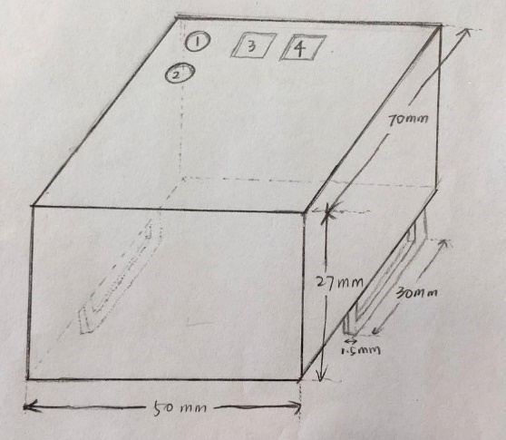

Figure 1: Device Housing Physical Design

# 2 Design

## 2.1.1 High Level Description

Our project features 2 almost-identical units, one for each foot. The device will be placed on top of the laces of the boot and secured by a strap that wraps around the outsole through the hole of the blade. For the device on each foot, one is designated as the master unit, and the other the slave. The only hardware difference is the lack of a physical button that is used for pair/sync/start/stop (depending on the current device state) on the slave device. Upon startup, the units should be in a rest state until the master unit initiates the pair up/syncing procedure (which in turn is initiated by the user pressing the button). The success of this sequence will be indicated by the status LED. Once paired and synced, the device will begin data collection, during which the microcontroller will sample the IMU and the force sensor in specified time intervals, and store it on the on-board microSD card. After a period of inactivity, or when the stop button is pressed on the master device, the data collection ends, and the slave unit will transmit all its collected data to the master unit. The master unit will combine the data collected from both devices and store them into the microSD card for post processing on the computer.

Top-level Diagram.png

Figure 2: High-level Overview

## 2.1.2 Device Software Finite State Machine

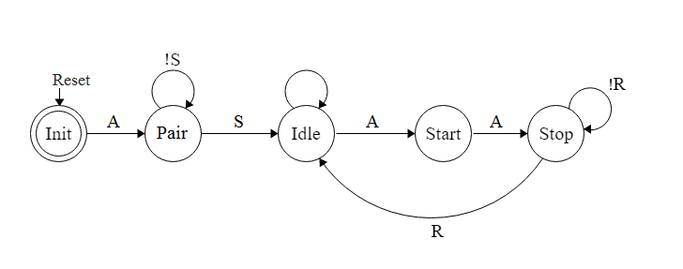

Figure 3: Device Software Finite State Machine (Master Side)

|  |  |
| --- | --- |
| **Input** | **Explanation** |
| Reset | Triggered by pressing the Reset button |
| A | Triggered by pressing the Sync button |
| S | Bluetooth pairing process success |
| R | Bluetooth data transmission success |

Table 1: Master FSM Input Explanation

|  |  |
| --- | --- |
| **State** | **Description** |
| Init | Initial setup state when reset is pressed |
| Pair | Pairing state, master sends out pairing signal P to slave |
| Idle | Wait state in between Bluetooth pairing and data collection process, or after slave data transmission at Stop state is finished; Status LED2 on |
| Start | Data collection in progress; Status LED2 on |
| Stop | Initiate slave data transmission; Status LED2 off |

Table 2: Mater FSM State Description

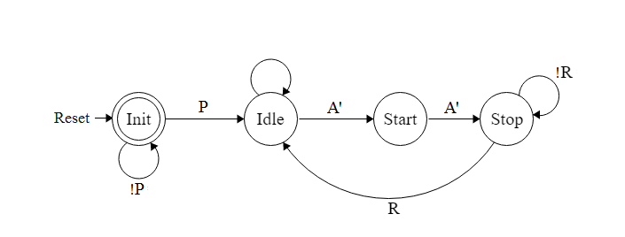

Figure 4: Device Software Finite State Machine (Slave Side)

|  |  |
| --- | --- |
| **Input** | **Explanation** |
| Reset | Triggered by pressing the Reset button |
| P | Pairing signal from master module |
| A’ | Signal A transmitted through Bluetooth |
| R | Bluetooth data transmission success |

Table 3: Slave FSM Input Explanation

|  |  |
| --- | --- |
| **State** | **Description** |
| Init | Initial setup and pairing state |
| Idle | Wait state in between Bluetooth pairing and data collection process, or after slave data transmission at Stop state is finished; Status LED2 on |
| Start | Data collection in progress; Status LED2 on |
| Stop | Data collection finished; Initiate slave data transmission; Status LED2 off |

Table 4: Slave FSM State Description

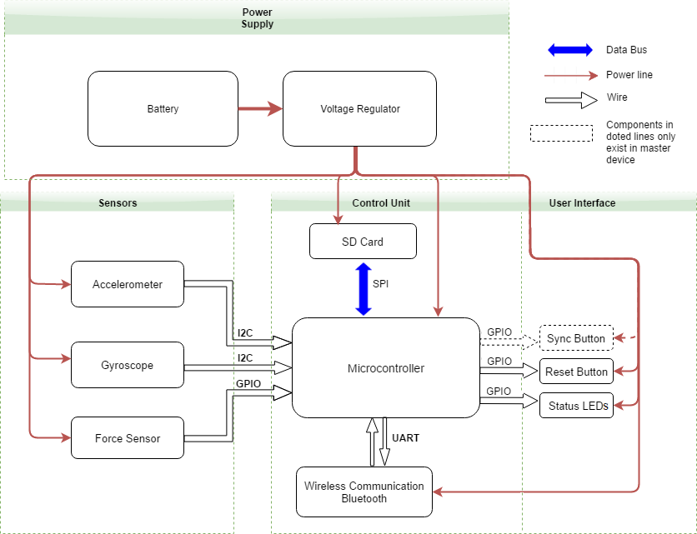

Figure 5: Hardware System Block Diagram

## 2.2 Block Descriptions

### 2.2.1 Power Supply

**Input:** 9V Alkaline Battery

**Output:** 9V directly to Microcontroller analog pin 25, 3.3V ± 5% to Microcontroller, force sensitive resistors, Bluetooth Transceiver, and IMU unit

The voltage regulator regulates the 9V battery input voltage to the 3.3V operating voltage for the individual modules. As shown in figure 8, capacitor C1 is connected between the input pin and ground to improve the power supply rejection ratio (the ability to maintain output voltage as input voltage is varied). Capacitor C5 is connected between output and ground for noise reduction.

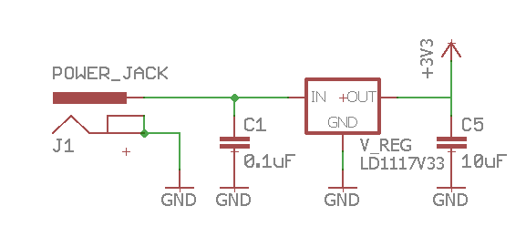

Figure 6: Power Supply Circuit

Since we expect our device to operate solely on the power supply unit for an extended amount of time, the durability of the battery is essential and requires careful testing. The circuit shown in Fig.9 could be used to test the power supply. For detailed steps refer section 2.3 and calculation 2.5.5.

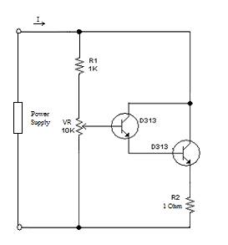

Figure 7a: Variable Load Circuit for Power Supply Testing

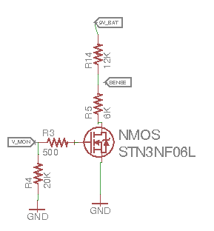

Figure 7b: Circuitry to Enable Battery Monitor

Figure 7b shows a voltage divider circuit that will be probed by pin 25 of the MPU to periodically monitor the voltage level, and therefore the battery capacity, of the 9V battery. Since keeping this circuit on at all times drains a significant amount of power, an NMOS is attached to act as a switch, so that the circuit is only active during probing.

|  |  |
| --- | --- |
| **9V Alkaline Battery (3 Points)** | |
| 1. Must supply voltage that is above the dropout range of the voltage regulator at a current draw of up to 100mA (2pt) | 1. Design a variable load test circuit with the multimeter monitoring the voltage across the supply  2. Tune the load resistance to adjust the load current to 100mA, measure the supply voltage drop and check if it is above the 4.3V margin(regulator voltage plus dropout voltage); |
| 2. The battery needs to support normal operation of the device for at least 1 hour (1pt) | 1. Connect a load to the battery that draws consistent current;  2. Check if the voltage of the battery is above 5V after 1 hour. |
| **Voltage Regulator (5 Points)** | |
| 1. Output voltage must be regulated to +3.3V ± 5% at a range of current draw (up to 100mA) as required by the modules (5pts) | 1. Connect the multimeter across the voltage regulator;  2. Check if the voltage drop between the input and output of the voltage regulator matches specification;  3. Use multimeter to track if the output voltage is stable;  4. Adjust the load current to 15mA and 30mA, respectively, repeat the above process. |

Table 5: Power Supply Unit RV Table

### 2.2.2 Status LEDs

**Input:** 3.3V power supply input, digital signals from the microcontroller

**Output:** Red light emitted from the LEDs

Referring back to the microcontroller circuit, there are two LEDs connected on pins PD6 and PD7. Status LED1(PD6) is used to indicate power (ON/OFF of the overall system), and status LED2(PD7) is used to indicate device FSM data collection state. The values of the current-limiting resistor are calculated by:

$\frac{(3.3-2)}{0.01}=130 Ohm$

|  |  |
| --- | --- |
| **Status LED (0 Points)** | |
| 1. At forward current of 10mA, the LED should emit red light and visible at direct viewing angle | 1. Connect the LED in series with a 330 Ohm resistor;  2. Use the multimeter to measure current through the LED;  3. At 10mA, make sure the LED light is visible from direct viewing angle |

Table 6: Status LED RV Table

### 2.2.3 I­­­­­­­nput Buttons

**Input:** 3.3V power supply input

**Output:** Digital signal to the microcontroller

There are two physical buttons connected to the microcontroller on the master device. The one on the INT0 pin serves as a reset button, utilizing the special interrupt hardware in the microcontroller. The one on pin PC3 acts as the pair/start/stop button, depending on the current state of the device.

|  |  |
| --- | --- |
| **Sync Button (0 Points)** | |
| 1. Buttons should be debounced and should indicate correct signal transition upon pressed | 1. Connect the button in series with a 330 Ohm resistor;  2. Supply 3.3 V;  2. Use the oscilloscope to monitor the voltage transition across the resistor, make sure the signal is debounced and correspond to correct digital value (digital “High” when pressed and “Low” when released) |

Table 7: Buttons RV Table

### 2.2.4 Microcontroller(ATmega328P)

**Input:** 3.3V power supply input, 3-axis acceleration data, 3-axis angular velocity data, 2 force-sensitive resistor voltage measurements, buttons, data from microSD card reader, data and signals from Bluetooth module

**Output:** Signals to sample the data from the combined 6-axis IMU, signal and data output to Bluetooth module

This module manages the data collection of the device by polling the IMU (inertial measurement unit; accelerometer + gyroscope) via the I2C interface as well as measuring the voltages across the two FSRs (force sensitive resistor). During collection, the data is buffered in the internal EEPROM and written into the microSD card through SPI in chunks of 512 bytes. During data transfer, the slave device reads the recorded data from its microSD card and transfers it to the master device via Bluetooth through the UART interface. The microcontroller is connected to a reset button on the hardware interrupt pin. In addition, the master device has a multipurposed button used to control its operating state.

This module is chosen based on its ability to handle serial communication of UART, SPI, and I2C at the transfer speeds shown in the calculations section. [7]

The module will be powered by 3.3V from a voltage regulator drawing power from a 9V battery. The circuit diagram of the microprocessor is shown below.

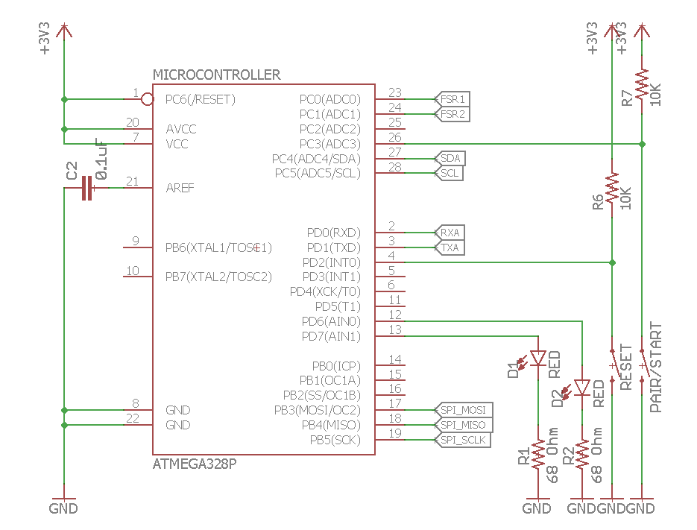

Figure 8: AVR Microcontroller Schematic

### 2.2.5 microSD Reader

**Input:** 3.3V power supply input, signal and data from microcontroller

**Output:** signal and data from the microSD card

The microSD card will act as the main storage device for the data collected. It connects to the microcontroller via SPI, and allows write to the SD card in 512 byte-chunks of data. This is a component external to our PCB, and will be connected via a 7-pin pin head port, as shown figure 6.

Figure 9: MicroSD Reader Schematic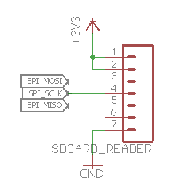

|  |  |
| --- | --- |
| **Requirements** | **Verification** |
| **AVR Microcontroller (15 Points)** | |
| 1. Module is capable of running UART at a baud rate of 115200 (3pts) | 1. Program the AVR to send 0x55 repetitively through the UART Tx pin 2. Probe the Tx pin with the oscilloscope 3. Verify the presence of a square wave with each pulse lasting ~8.68µs |
| 1. Device is capable of writing text files to the microSD card that can be read from a PC (7pts) | 1. Write a simple test program onto the AVR that uses the roland-riegel MMC/SD/SDHC card library to write 16-bit signed integers onto the microSD card 2. Verify on the PC that the number are readable and consistent with what was written |
| 1. Device is capable of monitoring the voltage of the battery when the MOSFET is ON. The reported voltage should be within ± 5%.(2pt) | 1. Get readings from the analog pin 25 that reports the voltage of the battery by using the formula Vbattery = 3\*Vadc;  2. Check if the voltage matches voltmeter readings. |
| 1. Device is capable of receiving data from the IMU via I2c at a minimum bitrate of 5580 bps (calculated requirement for maintaining the target 180 Hz sampling rate) (3pts) | 1. Orient the IMU such that the gyroscope has a constant non-zero reading  2. Pull data from the IMU at 180 Hz for a second  3. Verify that the quantity and validity of data received meets expectations |

Table 8: Microcontroller RV Table

### 2.2.6 Bluetooth Transceiver (HC-05)

**Input:** 3.3V power supply input, signal and data from microcontroller,

**Output:** Device-to-device signals between master and slave, data from microcontroller

The Bluetooth transceiver serves as the communication bridge between the master and the slave devices. The module runs on the UART ports of the microcontroller at 115200 baud in order to ensure a fast-enough data transfer rate during the data transfer state of both the master and the slave devices. The justification for this data rate is explained in the calculations section. This is a component external to the PCB and will be connected via a 4-pin pin head port, as shown in figure 5.

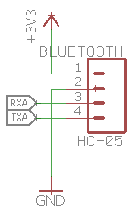

Figure 10: Bluetooth Transceiver Schematic

|  |  |
| --- | --- |
| **Bluetooth Module (5pts)** | |
| 1. Module is capable of receiving and transmitting over UART at a baud rate of 115200 (4pts) | 1. Program an Arduino to start serial communication at the baud rate of 115200 2. Use the Arduino to program the Bluetooth module to operate at baud rate 115200 3. Connect the Bluetooth module to an Arduino (Tx->Rx, Rx->Tx) 4. Short the Tx and Rx pins 5. Pair computer with Bluetooth module 6. Use a terminal program (eg. puTTY), connect to the correct serial line at baud rate 115200 7. Verify that what’s typed into the terminal is echoed back. If so, the loopback test is successful |
| 2. Two of such modules are capable of performing at the speed mentioned above when placed 2 ± 5% meters apart (1pt) | 1. Repeat steps 1-6 from the verification above 2. Pre-populate a string field of length 115200kb 3. Move the HC-05 2 meters away from the testing PC 4. Send the pre-populated string and check for accurate echo response |

Table 9: Bluetooth RV Table

### 2.2.7 Inertial Measurement Unit (IMU)

**Input:** 3.3V power supply input, polling signal from the microprocessor

**Output:** 3-axis acceleration data, 3-axis angular velocity data

This module contains a digital 3-axis accelerometer and a 3-axis gyroscope. For our purposes, we require the accelerometer to have a range of ± 16g, and the gyroscope to have a range of ±

125 dps (degrees per second). The targeted sampling rate for both the accelerometer and the gyroscope is 180 Hz each. This is to ensure high enough granularity for accurate data. The process of transferring data from the IMU to the microcontroller includes reading data value from one dimension of the IMU at a time. Thus, the microcontroller will read from the IMU at a frequency of 180 Hz; the reads from the IMU will rotate through all of its dimensions. When one set of all six dimensions has been read from the IMU, that will constitute to a successful poll. Thus, the microcontroller will poll at a rate of 30 Hz. Each read from the IMU will transfer two bytes of data. Data will be transferred vi

a the I2C protocol.

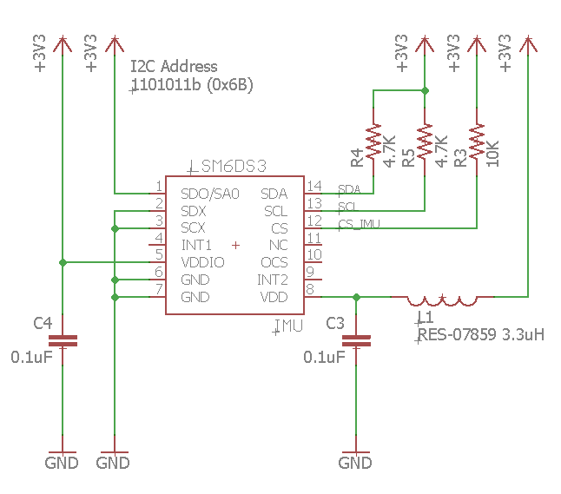

Figure 11: Inertial Measurement Unit Schematic

|  |  |
| --- | --- |
| **Accelerometer (5 Points)** | |
| 1. Acceleration output accurate up to 5%. | 1. Connect the accelerometer to microcontroller with test code on it. The test code will collect the acceleration data from the accelerometer.  2. Turn on the test circuitry and use one hand to hold the accelerometer about 6 inches above the other hand. Based on the accelerometer the x axis should be facing upward.  3. Drop the accelerometer from one hand to the other hand. Try to drop is so the accelerometer drops straight down and does not rotate during the fall.  4. Repeat step 2 and step 3 with the y axis and the z axis.  5. Port the collected data and graph it. Recommend using MATLAB but other scripting languages and environments could work too.  6. Plot the data and verify that when the accelerometer is held, the reading for the tested axis should be 1 g. Then the data should drop to 0 g when the accelerometer is falling. Both readings should be within the specified error margin. |
| 3. Samples at a rate of at least 180 Hz in order to give enough resolution to represent movement | 1. Connect the accelerometer to the microprocessor and load a test code that will collect and log the data from the accelerometer  2. Obtain a stopwatch to record the time data is collected. Collect data for 10 seconds.  3. Analyze the data collected to ensure that there are enough entries to meet the requirement of 180 Hz (for 10 seconds example there should be at least 1800 entries) |
| **Gyroscope (5 Points)** | |
| 1. Accurate up to ± 7 degrees in order to assure accuracy in data | 1. Connect the gyroscope to a microcontroller that has test code to collect data from the gyroscope.  2. Turn on the test circuitry with the gyroscope lying flat.  3. Rotate the x axis (roll) 90 degrees and then rotate back to initial position.  4. Repeat step 3 for the y axis (pitch) and z axis (yaw).  5. Port the collected data and graph it. Recommend using MATLAB but other scripting languages and environments could work too.  6. Plot the data and verify that the axis being tested reaches 90 degrees or is within the error margin. The data should also reach 0 degrees when rotated back to the initial position. If the data collected is the raw angular velocity then, integrate it before plotting. |
| 2. Samples at a rate of at least 180 Hz in order to give enough resolution to represent movement | 1. Connect the gyroscope to the microprocessor and load a test code that will collect and log the data from the gyroscope  2. Obtain a stopwatch to record the time data is collected. Collect data for 20 seconds.  3. Analyze the data collected to ensure that there are enough entries to meet the requirement of 180 Hz (for 20 seconds example there should be at least 3600 entries) |

Table 10: IMU RV Table

### 2.2.8 Force Sensitive Resistors with Passive Low-pass Filter

**Input:** 3.3V power supply input, physical force applied to the sensor area

**Output:** Resistance change reflected by voltage level to the microcontroller

The force sensitive resistors (FSR) serve as the force sensor in our design. The amplitude of the pressure will be reflected by the resistance of the FSR. There will be two FSRs installed beneath the insole of each skate. FSR1 will be placed between the third and fourth toe mounds and FSR2 will be placed on the heel area. The sensors will each be connected in series with a 20kOhm reference resistor. The output terminal is connected to the output port of an Op-Amp to improve accuracy of the force sensor. In reality, because the ADC(analog input) pins of the microcontroller have a load impedance of only around 10 kOhms. This finite load impedance is connected in parallel with the reference resistor, making the equivalent reference resistance less than the 20kOhm nominal value. Therefore, it is necessary to include the Op-Amp in our design. In addition, the natural vibration during skating due to the uneven ice surface that causes high frequency noises of the analog data requires denoising of the data. As a result, we decided to design a low-pass filter with a cut-off frequency of 20Hz(this is a theoretically value we are using ). More force calculation will be discussed in depth in section 2.5.3.

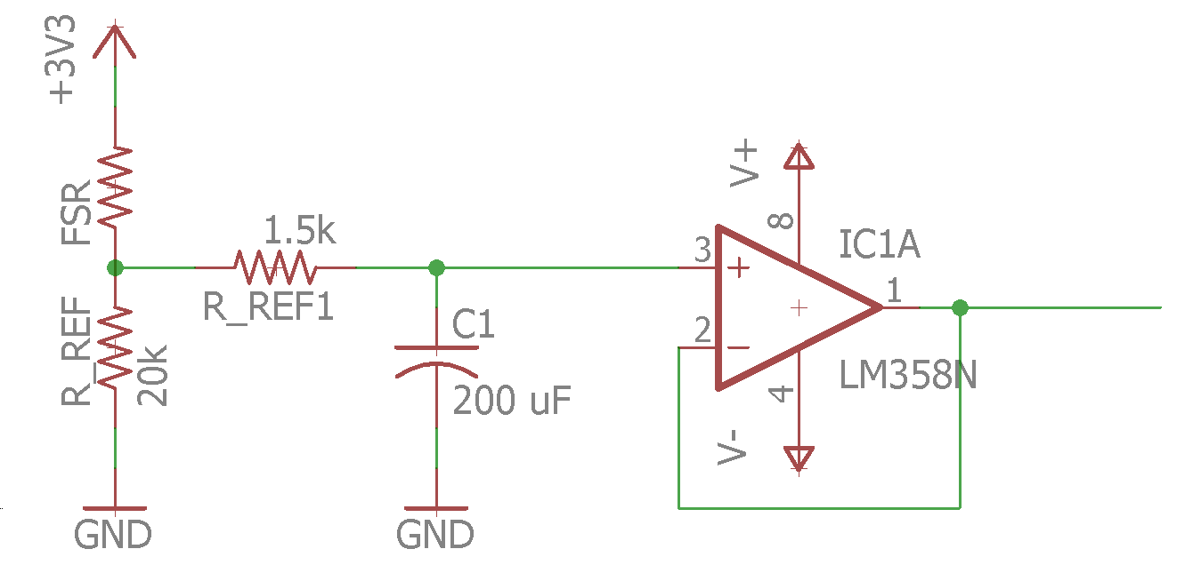

Figure 12: FSR Schematic with Low-Pass Filter

|  |  |
| --- | --- |
| **Force Sensitive Resistor and Low-pass Filter (12 Points)** | |
| 1. Pressure measurement range needs to be from 1psi to at least 6.409psi (Equivalent: force measurement range needs to be between 14-90N);  The measurement needs to be within ±10% of the theoretical value at the two boundary values. (4pts)  \*see derivation of the values used here in the calculation and simulation section | 1. Place the FSR on a flat surface and connect the FSR in series with a 20 kOhm reference resistor Rref;  2. Supply 3.3V voltage across the two resistors;  3. Place a 1.4kg weight on top of the FSR;  4. After the readings stabilize, measure the voltage drop across the reference resistor, Vref;  5. Find VFSR by using the relation VFSR = 3.3V - Vref and then find the current across the components I = Vref / Rref;  6. Use the voltage and current found to calculate FSR resistance, compare with theoretical value and check if it is within 10% error margin;  7. If the value does not match the standards, change the weight until the value meets the requirement, record the adjusted value and check if it is among a reasonable range;  8. If the value matches the standards, move on to replace the 1.4kg weight with a 9.2kg weight and repeat the above steps. |
| 2. Measurement result needs to be accurate within ±10% of the theoretical value (3pts) | 1. Select 5-10 weight values between the two threshold values;  2. Repeat the same steps as specified in part 1 of FSR verification and record the corresponding measurements;  3. Use the values obtained to plot the Pressure vs Force curve, fit a trend line;  3. Check if the trendline matches theoretical curve as shown in Fig. 4 and the points have less than ±10% error. |
| 3. Must draw current less than 1uA at resting state (2pt) | 1. Supply 3.3V voltage across the resistor;  2. Measure the current drawn from the supply using the multimeter; |
| 4. The low-pass filter must have -3dB frequency of 20Hz ± 10%; (3pt) | 1. Use the function generator to generate a sinusoidal input with amplitude of 50mV at frequency of 5Hz and slowly increase the frequency to 30Hz while using the oscilloscope to monitor the amplitude;  3. When the amplitude dropped to $35.34mV$, verify that it is within ± 10% of 20Hz. |

Table 11: FSR RV Table

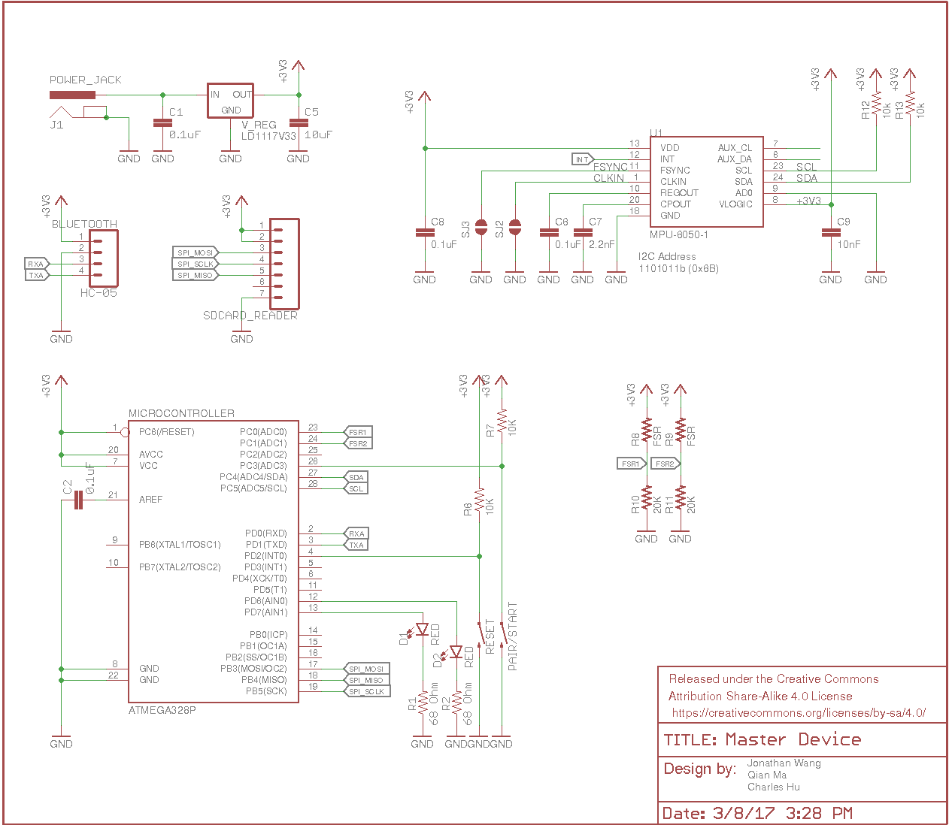

Figure 13: Overall System Schematic

## 2.3 Software Description

### 2.3.1 Post Processing Software

Software_overview (3)

Figure 14: Software Flowchart

**General**

The above flow chart shows the general procedure of the post processing software. This procedure is meant to analyze the data obtained by the device and give meaningful feedback to user on their skating form. The base code will detect differences between the user’s left and right leg skating form and notify the user accordingly. This procedure will be prototyped in MATLAB.

**Load and Organize**

The SD from the master device will first be inserted into a computer, and then a script will be run to facilitate the whole process. Initially the data from the SD card will be loaded off and organized into array form, two for data collected from the accelerometers, two for data collected from the gyroscopes, and four for data collected from the force sensors. All of the arrays will be timestamped or have a time array in relation to sensor collected data. Once the data is successfully loaded off the SD card, the analysis algorithm will be run.

**Analysis Algorithm**

The analysis algorithm is meant to detect asymmetry between the right and left legs and also determine if the user’s form fulfills the metrics that determine efficient skating. The analysis algorithms described below will calculate metrics for both right and left leg. These metrics will then be compared in order to determine if the user’s skating form is symmetric. Symmetry is characterized with the following proposed equation, the Weighted Extracted Asymmetric Ratio (WEAR). $x_{left}$ defines the left metric that is being compared and $x_{right}$ defines the right leg of the same metric. If the WEAR is true then the user is asymmetric for the compared metric.

$$\frac{\left|x_{left}-x_{right}\right|}{\min{\{x_{left}, { x}_{right}\}}}>0.1$$

There are certain quantitative metrics that the algorithm will look for in order to determine efficient skating. The first quantity deals with the skate angle. During a stride, where a leg pushes to propel the user forward, the skate should make a 45 degree angle with the ice. This ensures that the skate has the maximum grip on the ice and therefore maximizes the efficiency of the stride. The second quantity being looked at is the largest translational displacement of skate. This is information will be compared to the length of the user’s leg to make sure that the user is fulling extending during the strides. The length of the leg will either be inferred based on the user’s height input or through calibration.

The overall algorithm can be split up into three phases. Phase 1 will set time markers for the data set. The purpose of the markers is to set boundaries between each stride. Phase 2 involves analyzing the weight transfer from the heel to the toe during the stride. Phase 3 will calculate the translational and angular displacement within each stride. The markers set in phase 1 will be used to determine the rough beginning and end of each stride.

Phase 1

This phase breaks down the data that is collected into sets of data; each set of data represents one stride. This is necessary for calculating displacement from the acceleration data.

Calculating displacement strictly from acceleration data introduces inaccuracies, which gets compounded the more the calculation goes on. Therefore the displacement calculation will be done strictly within each stride data set. We believe this way the inaccuracies will not affect the results that much.

The algorithm for this phase is proposed based on the force data collected from previous research [1]. We assume that heel force we plan to collect will look similar to the researches force data. Thus the algorithm will first calculate the peaks of the waveform. MATLAB has a library for detecting peaks in noisy signals. Then “period markers” will be placed at times in between each peak. These period markers will essentially split the data into sections; the data in each section will represent one stride.

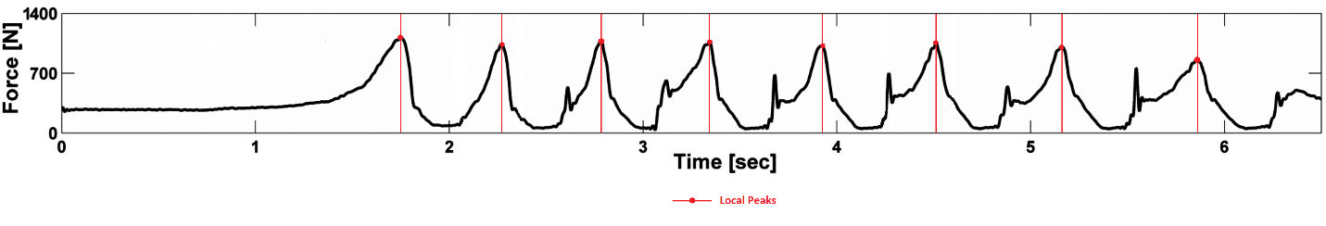

Figure 15: Using Force Data for Stride Definition [1]

Phase 2

This phase also analyzes the force data, except the analysis will compare the heel force data with the toe force data. The purpose is to quantify weight transfer from the heel to the toe during a stride. Then weight transfer for the left leg and right leg is checked for symmetry.

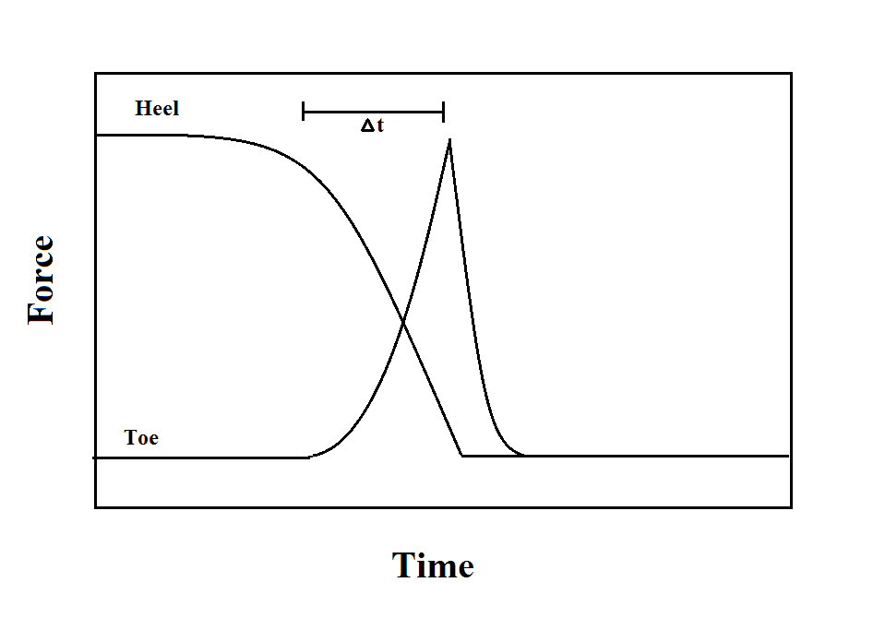

Figure 16: Theoretical Overlay of Force Plot

The analysis for one foot will overlay the heel force data with the toe force data. Theoretically, the force from the heel should peak first and then decrease. At the same time the force from the toe would increase and peak around when the heel force is at a minimum. When skating efficiently the weight should be transferred from heel to toe during a stride. The time difference between the heel peak and toe peak is then calculated. This metric will be used to compare the left side to the right side. The force data is also periodic, so the metric calculation will be done for each stride, defined by the markers, and then averaged. The averaged left and right time difference is then used in the WEAR to determine symmetry. We believe that if the user has an asymmetrical habit then averaging the time difference for all the strides of one foot will not compromise the comparison of the left and right legs. This is because the habit theoretically should be evident in all the user’s strides.

Phase 3

In this phase, the algorithm will calculate the translational and rotational displacement based on the collected acceleration data. Both translational calculations will be done within each stride data set. The result of the calculations will be used for symmetric comparison and to compare with the quantitative metrics that were described above.

For symmetry analysis, the max translational displacement for each stride will be gathered and then averaged for each leg. Then the averaged values will be used in the WEAR to determine if the user’s leg extension is symmetrical. The same is done with the rotational data; the feedback is used to determine if the user is opening his/her hips enough during the stride and if their skate is gripping the ice at the same angle.

Then the translational displacement will be parsed to check if the user fully extended his/her knee during each stride. The same thing will be done with the rotational data to make sure that the user’s skate is at about 45 degrees to the ice during each stride.

**GUI**

After data analysis is performed, the calculated output is transferred to the GUI. The GUI will output the calculated displacements on time related graphs. It will also display a force graph where the heel and toe force data are overlaid over each. The outputs of the WEAR will also be displayed as feedback to the user.

## 2.4 Calculation and Simulation

### 2.4.1 Current and Power Calculation

|  |  |  |  |
| --- | --- | --- | --- |
| **Load** | **Operating Voltage** | **Current Draw**  **(Active Mode)** | **Current Draw**  **(Sleep Mode)** |
| Microcontroller | 3.3V | 4.0 mA | 4.0 uA |
| IMU Unit | 3.3V | 1.25 mA | 425 uA |
| Force-Sensitive Resistor | 3.3V  (in series with Rref) | Max:  0.066m A | 0 mA |
| Bluetooth Module | 3.3V | 40 mA(pairing)  8 mA(active) | 3 mA |
| LED (2) | 3.3V | 10 mA | 0 mA |
| Voltage Regulator | 9V | 5mA | 0 mA |
| microSD Card | 3.3V | 30mA | 200 uA |

Table 12: Component Current Draw

Max total Current Draw (active) = 100.316 mA

Dynamic Power (active max) = V\*I = 331.043 mW

Normal total current Draw (active) = 62.316 mA

Dynamic Power(active) = V\*I = 205.643mW

Total Current Draw (sleep) = 3.629 mA

Dynamic Power(sleep) = 11.976 mW

9V Alkaline Battery Capacity = 500 mAh

Battery life for max active usage: 500/100.316 = 4.84 h

Battery life for normal active usage: 500/62.316 = 8.02 h

Battery life for sleep mode: 500/3.629 = 137.78 h

### 2.4.2 Sensor Resolution

**IMU acceleration:**

The LSM6DS3 provides the configuration of ±2g, ±4g, ±8g, and ±16g range. With the intensity of ice skating activity [1], it is necessary that our design uses the ±16g scale where g is the gravitational acceleration with value 9.81 $m/s^{2}$. Therefore, the resolution of the acceleration data is:

$Acceleration Resolution= \frac{|Measurement Range|}{2^{number of data bits}}= \frac{16g}{2^{15}}=4.79 mm/s^{2}$ (1)

**Force measurement Resolution:**

The output of FSR is a continuous analog voltage, which will be converted to an 8-bit unsigned value. Data loss will occur during conversion to 256 digital levels. The voltage ranging from 0 to 3.3V will be converted into an unsigned integer from 0 to 255. Therefore, the lowest voltage interval that can be resolved is:

$FSR Voltage Resolution= \frac{|Measurement Range|}{2^{number of data bits}}= \frac{3.3}{2^{8}}=12.89 mV$ (2)

Due to the non-linearity of the voltage and pressure relationship, each voltage interval will represent different pressure difference. For detailed discussions refer to section 2.4.3.

2.4.3 Force Calculation

In the below calculation, we are making the following assumptions:

1. The maximum force during acceleration is 1000N [1], the value accounts for both the weight of the skater and the force exerted during acceleration;
2. The pressure applied is evenly distributed over the area of the foot;

To find the approximate value for area of the foot, we will be using the average American shoe size of 8.5 for women and 10.5 for men. Since the area is inversely proportional to pressure, to find maximum pressure, we will use size 8.5 in the calculation.

Approximate foot area:

$A_{f} = 24.6cm × 9.2cm = 226.32 {cm}^{2} = 0.0226 m^{2}$ (1)

Maximum pressure:

$P_{max} = \frac{F}{ A_{f}}= \frac{1000N}{ 0.0226m^{2} }= 44185.2 Pa=6.409 psi$ (2)

1 inch Diameter Sensor Area:

$A_{sensor}= π × {(0.5)}^{2} {inch}^{2}=0.00202677m^{2}$ (3)

Maximum force applied to the sensor:

$F_{max}= P_{max} × A_{sensor}=44185.2 ×0.00202677=89.55 N$ (4)

With the known values from the datasheet [5] provided by the manufacturer, we were able to fit a trendline as shown in the figure below. The trendline has a coefficient of determination $R^{2}=0.9991= 99.91\%<5\%$ error margin.

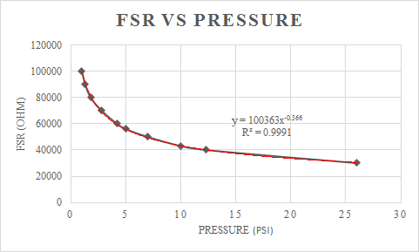

Figure 17: Low Pressure FSR Values with Trendline

Within the range of 1psi to 25psi, the FSR behavior follows a power curve of: $FSR=100362*P^{-0.366}$ 
 (5)

With equation (5), we can get the following relation: $P={(\frac{100362}{FSR})}^{\frac{1}{0.366}}$ 
 (6)

Based on figure shown below, the calculation from analog voltage to FSR value is as follows:

Voltage devider rule:

$\frac{V_{OUT}}{3.3 V}= \frac{20k}{20k+FSR}$ (7)

$FSR= \frac{66k}{V_{OUT}}- 20k Ohm$ (8)

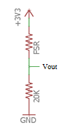 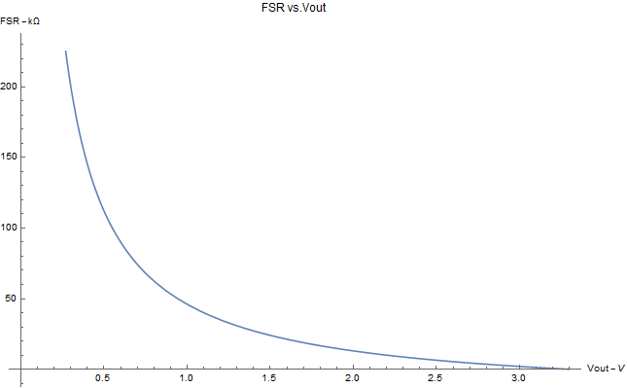

Figure 18: FSR Configuration Figure 19: FSR vs Vout

Combining (6) and (8), then we can derive the formula to calculate pressure from the analog voltage:

$P={(\frac{100362}{\frac{66k}{V_{OUT}}- 20k})}^{\frac{1}{0.366}} psi$ (9)

Notice that there are a few factors that contribute to the non-linearity of the relationship. Firstly, the relationship between pressure and analog output voltage is non-linear. Secondly, the analog voltage will be converted to 256 digital levels, which implies that each voltage interval represents different pressure change.

### 2.4.4 Data Collection Rate Justification

Since our device functions as a data logger, the data collection and transfer rates must be carefully considered.

From our research and observation on typical IMU outputs, we’ve determined that a sampling rate of 30 Hz from all sensors provides the best overall balance between ease of process, usefulness, and economizing the data storage used.

At 30 Hz, we must finish polling all sensors within:

$\frac{1}{f}=\frac{1}{30}=33.3 ms$ (1)

**IMU data via I2C:**

Since we’re polling the data one axis at a time in sequence, we must poll 6 times from the IMU to form one complete set of data. From each poll, we expect a 2-byte data [6] from each axis.

Combining data from all six axes:

 (2)

Since the I2C transfer rate is 400 kb/s (50 B/ms), all the data is expected to be transferred within:

$\frac{12 bytes}{50 B/ms}=0.24 ms$ (3)

This is a lower bound, as we expect to write in timestamp information along with the data collected.

Since 0.24 ms < 33.3 ms, I2C is capable of transferring all the data in time.

**Storage with SD Card:**

We expect two 1-byte data from the analog pin connected to the FSR. Therefore, we must store 14 bytes of data at 30 Hz, which requires a rate of:

$\left(12+2\right)bytes ×30 Hz=420 Bps$ (4)

The microSD card is written in blocks of 512 bytes, and will take an average of 20 ms to write. Since our 30 Hz gives us ~33 ms between each poll, the data must be buffered in 512-byte blocks in the internal EEPROM, so as to not disturb with the flow of data collection.

**Bluetooth Baud Rate:**

We specified the Bluetooth to be working at a higher baud rate than default due to the amount of data that needs to be transferred. For a 10-minute session, we expect 25.2 MB of data. At 115200 baud, we have 115.2 kb/s, which converts to 14400 KB/s. With 25.2 MB of data, it takes 1.75s to complete the transfer, without taking into account bookkeeping bits. The default 9600 baud is only 8% of this speed, and is therefore unsuitable for this task.

### 2.4.5 Variable Load Current Testing Circuit Analysis

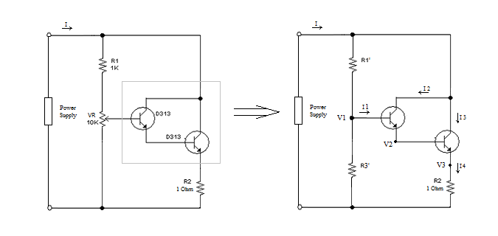

Figure 20: Variable Load Circuit Analysis

We designed a variable load circuit to test the stability of our power supply by utilizing the current amplifying properties of Bipolar Junction Transistors. As shown in Fig.17, we can draw the equivalent circuit to simplify the analysis.

The two BJTs form a Darlington pair, which is commonly used to amplify small current [8].

We know from the characteristics of BJTs that:

$V_{1}- V_{2}= V_{2}- V_{3}=0.7V$ (1)

If we use two identical BJTs with DC current gain β, then:

$I_{2 }= βI_{1}$ (2)

$\frac{I_{4}}{I_{3}}=$ β+1 (3)

Combining (2) and (3), we get:

$I_{4}={(β+1)}^{2}I_{1}$ (4)

Using Ohm’s Law,

$V_{3}= I_{4}R_{2}$ (5)

$V_{1}= I_{4}R_{2}+1.4$ (6)

Using KCL:

$I=I_{4}+ \frac{V_{1}}{ R_{3}^{'}}$ $≈ I_{4}$ (7)

Once we know the voltage $V_{1}$, we can calculate $I_{1}$ accordingly. By varying the ratio of $R_{1}^{'}$ and $R_{3}^{'}$, we can tune the total current I.

## 2.5 Tolerance Analysis

Most of the components in our device are durable and can withstand small fluctuations in accuracy within a defined margin. However, the IMU data contains measurements of six axes, which increases the probability that errors exceeding the ±5% threshold. In addition, accuracy of the IMU data is essential because any errors in the measurement data will propagate to the post-processing software program, which will lead to failure in providing accurate feedback. Thus, we conclude that our inertia measurement unit is the critical component. The IMU must have a certain level of accuracy to successfully analyze the user’s skating form.

We define the tolerance levels for the IMU to be the following:

* Accelerometer’s tolerance allows data to be accurate if within 1 cm.
* Gyroscope’s tolerance allows for ±5 degrees in any direction

These tolerance standards must be met for the data to be deemed accurate for analytical processing.

Inaccuracy of the sensor can propagate throughout the analysis algorithm. For instance, let one IMU’s gyroscope overshoot its accuracy by 5 degrees. Then for example average angle obtained from the faulty gyroscope is 45 degrees and the non-faulty IMU outputs an angle of 40 degrees. However, both IMU’s should have outputted 40 degrees. If both outputted 40 degrees, then the analysis would say that the skater has symmetry for the angular rotation metric. But with the faulty IMU the calculation for symmetry goes as such:

|45 - 40| / 40 = .125

This result would dictate asymmetry, which is false.

The accelerometer and gyroscope both contain three axes. The data for each axis is stored as a 16-bit signed integer with 1 sign bit store the sign of the signal and 15 data bits storing the magnitude. Therefore, if we assume each data bit has a probability of p to fail, then the 15-bit sequence forms a Binomial Distribution B (15, p).

The mean of the distribution: 15p

The variance of the distribution: 15p(1-p)

For either gyroscope or accelerometer, the probability that all three axes, a total of 45 data bits are error free is: $P_{zero-error} = {(1-p)}^{45}$

Therefore, the probability that some error will occur would be:

$P_{error} =1- P_{zero-error}= {1- (1-p)}^{45}$

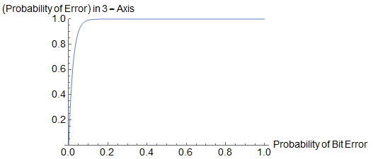

Figure 21: Probability of Error in 3-Axes of Data

# 3 Ethics

## 3.1 Ethics Justification

This product is purposed to help people maximize their efficiency while skating. We believe that this purpose and the device’s implementation is strictly following the IEEE Code of Ethics, #9:” to avoid injuring others, their property, reputation, or employment by false or malicious action;” [4]. We plan to stick to our purpose during the whole process, and everything will be documented for complete transparency. The documentation will not only act as proof showing that we did not deviate from our original goal but also be part of our effort to follow the IEEE Code of Ethics, #3: “to be honest and realistic in stating claims or estimates based on available data;” [4]. Throughout our design process, we will take responsibility to address the potential safety issues and make every effort to minimize them. We believe that this is our commitment to the IEEE Code of Ethics, #1:” to accept responsibility in making decisions consistent with the safety, health, and welfare of the public, and to disclose promptly factors that might endanger the public or the environment;” [4].

## 3.2 Safety

Based on the design components, there are a few potential safety concerns:

### 3.2.1 Device Overheating

As with most electronics there is always a possibility that a device could overheat based on unforeseen circumstances. In our case, the sealed packaging might lead to increased temperature. As mentioned in section 2.5.1, the power consumption during active mode is around 330 mW and less than 12 mW during sleep mode. For safety precautions, we would recommend that the user switch the device to sleep mode after 10 minutes of active use. In the unlikely chance that our device overheats, the safety concern would be sustained burns due to handling the device. The overheating device could also damage the skates or the laces but safety issue regarding that would be minimal.

### 3.2.2 Battery Safety

Considering that the device will mostly operate in ice rink with potential water contact, the sealed housing is essential to reduce risks related to battery. Among the battery options available to supply a small low powered device for an extended period of time, we decided that the 9V alkaline battery is a suitable choice. Compared to Li-Po batteries, alkaline batteries are much less likely to cause fire hazards. In addition to fire hazards, we do need to address that the electrolyte in these cells is potassium hydroxide (KOH), which is caustic and can cause tissue damage when in contact with skin. Therefore, one should avoid direct contact with the battery if there is potential leakage.

### 3.2.3 Hardware failure

In the case of a hardware failure, everything will most likely be contained due to the sealed packaging. There will also be no shorting issues because the boot of the skate will act as an insulator between the device and the user’s foot.

### 3.2.4 Mounting failure

There is a possibility that mount could fail and the device falls off while the user is skating. This could cause injury to the user or those around him/her should they accidently trip over the device.

# 4 Cost and Schedule

## 4.1 Cost Analysis

### 4.1.1 Labor

|  |  |  |  |  |
| --- | --- | --- | --- | --- |
| Team Member | Hourly Rate | Hours | Total | Total x 2.5 |
| Charles Hu | $30 | 200 | $6,000 | $15,000 |
| Qian Ma | $30 | 200 | $6,000 | $15,000 |
| Jonathan Wang | $30 | 200 | $6,000 | $15,000 |
| **Total Labor** |  |  |  | **$45,000** |

### Table 13: Labor Cost

### 4.1.2 Parts

|  |  |  |  |  |
| --- | --- | --- | --- | --- |
| Item | Quantity | Vendor | Cost/unit | Cost |
| ATMega328P | 2 | SparkFun | $4.3 | $8.6 |
| Wireless Bluetooth RF Transceiver Module Serial RS232 TTL HC-05 | 2 | Amazon | $6.61 | $13.22 |
| IMU – MPU6050 | 2 | InvenSense | $5.45 | $10.9 |
| 1 Inch ShuntMode FSR | 4 | Sensitronics | $6 | $24 |
| Voltage Regulator - 3.3V | 1 | SparkFun | $1.95 | $1.95 |
| LEDs | 3 | Amazon | $0.175 | $0.525 |
| 9V Energizer 522 Battery | 2 | Amazon | $3.82 | $7.64 |
| microSD Reader | 2 | SparkFun | $4.95 | $9.90 |
| **Total** |  |  |  | **$72.705** |

Table 14:Parts Cost

### 4.1.3 Grand Total

**Grand total = Parts Cost + Labor = $45,072.975**

## 4.2 Schedule

|  |  |  |
| --- | --- | --- |
| **Week** | **Task** | **Responsibility** |
| 1/16/17 | **Initial Post Due** | All |
| 1/23/17 | Come up with a project idea | All |
| Apply for RFA | All |
| 1/30/17 | **Project Approval Due** | All |
| Work on proposal | All |
| 2/6/17 | **Project Proposal Due** | All |
| Work on design documentation | All |
| 2/13/17 | **Mock Design Sign-up Closes** | Qian |
|  | Work on design documentation | All |
| 2/20/17 | **Design Review Sign-up Closes** | Jonathan |
|
| **Design Document Due** | All |
| Attend mock design review | All |
| 2/27/17 | **Attend Design Review** | All |
| Purchase Parts | All |
| Build power supply and test | Qian, Charles |
| Check microprocessor for RV and upload basic code | Jonathan |
| 3/6/17 | Purchase parts; Integrate microprocessor and interface with IMU | Jonathan |
| Write test code for IMU, load onto microprocessor | Qian |
| Test IMU for RV, integrate with microprocessor | Charles |
| 3/13/17 | Design PCB | All |
| Test Force Sensor for RV, integrate with microprocessor | Qian |
| Test SD card for RV, integrate with microprocessor | Jonathan, Charles |
| Collect specification for casing to give to machine shop | Qian |
| 3/20/17 | **Spring Break**/ Buffer Week | All |
| **Last Day for First Revision of PCB** | All |
| Work on individual progress reports | All |
| 3/27/17 | **Individual Progress Reports Due** | All |
| **Last Day for Revisions to Machine Shop** | All |
| Test Bluetooth module for RV and integrate into device | All |
| Finalize PCB design | All |
| 4/3/17 | **Last Day for Revised PCB** |  |
| Implement processing algorithm | All |
| 4/10/17 | Design GUI for user feedback | Qian, Charles |
| Solder components onto PCB and test | Jonathan |
| 4/17/17 | **Mock Demo** | All |
| **Demonstration Sign-up Closes** | All |
| **Mock Presentation Sign-up Closes** | All |
| **Presentation Sign-up Closes** | All |
| Verify device, debug problems, buffer week | All |
| Prepare presentation and demonstration | All |
| 4/24/17 | **Mock Presentation** | All |
| **Demonstration** | All |
| Finalize verification | All |
| Start writing final report | All |
| 5/1/17 | **Final Papers Due** | All |
| **Lab Notebook Due** | All |

Table 16: Weekly Schedule

# Bibliography

[1] E. Buckeridge, M. C. LeVangie, B. Stetter, S. R. Nigg, and B. M. Nigg, "An on-ice measurement approach to Analyse the Biomechanics of ice hockey skating," PLOS ONE, vol. 10, no. 5, p. e0127324, May 2015.

[2] J. Pearson, "Researchers at Brigham young developed a smart skate," in MOTHERBOARD, Motherboard, 2014. [Online]. Available: https://motherboard.vice.com/en\_us/article/this-smart-skate-measures-how-hard-figure-skaters-land. Accessed: Feb. 8, 2017.

[3] X. Robert-Lachaine, "Force measurement and ankle motion of the forward skating and crossovers with a standard hockey skate and a modified hockey skate," 2010.

[4] "IEEE code of ethics," in IEEE.org. [Online]. Available: http://www.ieee.org/about/corporate/governance/p7-8.html. Accessed: Feb. 8, 2017.

[5]"1" Shunt Resistance Resistance vs. Pressure," Sensitronics. [Online]. Available: http://www.sensitronics.com/product-res/1-inch-shunt-mode-fsr/docs/1-inch-shunt-mode-medium-res.pdf. Accessed: Feb. 25, 2017.

[6]"LSM6DS3: Always-on 3D accelerometer and gyroscope - Application Note," STMicroelectronics, 2017. [Online]. Available: http://www.st.com/content/ccc/resource/technical/document/application\_note/12/98/b4/44/a5/bf/4e/c5/DM00157511.pdf/files/DM00157511.pdf/jcr:content/translations/en.DM00157511.pdf. Accessed: Feb. 25, 2017.

[7]"ATmega328/P DATASHEET SUMMARY," Atmel, 2016. [Online]. Available: http://ww1.microchip.com/downloads/en/DeviceDoc/Atmel-42735-8-bit-AVR-Microcontroller-ATmega328-328P\_Summary.pdf. Accessed: Feb. 25, 2017.

[8]Hamuro, "Variable dummy load for power supply testing," 2013. [Online]. Available: http://www.deeptronic.com/electronic-circuit-design/variable-dummy-load-for-power-supply-testing/. Accessed: Feb. 27, 2017.